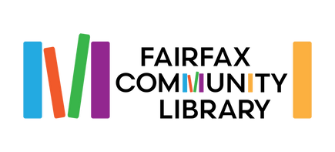
Fairfax Community Library
BFA School Board
Joint Board Meeting
Thursday, October 19, 2023
6:30 PM

Call to Order
Approval of minutes for April 20, 2023, Joint Board Meeting
Correspondence
Highlights of Quarterly Reports – Librarians

Updates:
Community Library Staffing
Early Literacy Project/Elementary Book distribution

New Business:
Highlights of school policies/procedures which impact the library
School Renovations (impact on library space & operation)

Other:

