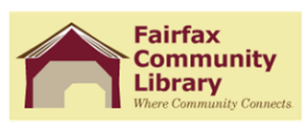
Fairfax Community Library
BFA School Board
Joint Board Meeting
Thursday, April 28, 2022
6:30 PM

Call to Order
Introductions
Approval of minutes for October 21, 2021, Joint Board Meeting
Correspondence
Highlights of Quarterly Reports – Librarians

Updates:
Library Insurance
New Community Library Staff
Compensation Study
Early Literacy Project

New Business:
Highlights of school policies/procedures which impact the library
Share update of Fairfax Community Library Unattended Children Policy
Trustees currently working on update to the Patron Code of Conduct Policy

Other:

