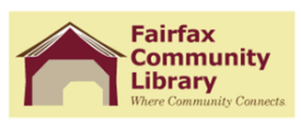

Fairfax Community Library
BFA Fairfax School Board
Joint Board Meeting
Thursday, April 15, 2021 6:30 PM

Call to Order
Introduction New Members
Public Input
Approval of minutes of October 22, 2020
Correspondence
Highlights of Quarterly Reports – Librarians

Updates:

Early Literacy Project
Library Policies updated (Donation Policy, Strategic Plan, By-laws)

New Business:

Recently created or updated school policies
Library/School partnership to expand in-person visits (summer)

