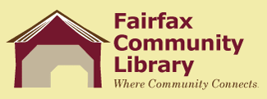
Fairfax Community Library
BFA Fairfax School Board
Joint Board Meeting
Thursday, October 21,2021

Call to Order

Public Input
Approval of minutes for April 15, 2021, Joint Board Meeting
Correspondence
Highlights of Quarterly Reports- Librarians

Updates:
*Early Literacy Project
*American Rescue Grant

New Business:
*Highlights of school policies/procedures which impact the library
*Staff: Part time Circulation Assistant and Substitutes
*Insurance Coverage for Library

Other:

